OpenMarket: A Buy & Sell Mobile Marketplace Application
COSC 468: Mobile Programming — Final Project Report

Abdulla Madan — S2400025 — Project Lead & iOS/Backend Developer
Ziyad Alhajri — F2300078 — UI/UX Designer & Frontend Developer
Ahmed Qarooni — F2300082 — Backend Developer & QA Engineer

Institution: American University of Bahrain, College of Engineering
Course: COSC 468: Mobile Programming, Section 001, Spring 2026
Instructor: Dr. Bara Alalawsh
Submitted: 5th May 2026

Abstract
This report presents the design, architecture, and implementation of OpenMarket, a full-featured iOS marketplace application developed as the final project for COSC 468: Mobile Programming at the American University of Bahrain. OpenMarket enables users in Bahrain to post items for sale, browse and search listings by category, price, condition, and GPS proximity, negotiate prices through a structured offer-and-counter-offer workflow, communicate via real-time WebSocket messaging, and rate sellers after transactions. The application is built with SwiftUI following the Model-View-ViewModel (MVVM) architectural pattern on iOS, backed by a RESTful API server implemented in Go using the Gin framework with SQLite persistence via the GORM ORM. All nine core features specified in the project brief have been fully implemented and validated through unit testing, integration testing, and manual user-acceptance testing. The system demonstrates mastery of mobile development frameworks, scalable software architecture, real-time communication, location services, and secure authentication practices.
Keywords — SwiftUI, MVVM, iOS, marketplace, Go, REST API, WebSocket, CoreLocation, MapKit, JWT

I. INTRODUCTION
Mobile marketplace applications have transformed the way individuals buy and sell second-hand goods. Platforms such as OpenSooq, Facebook Marketplace, and Craigslist have demonstrated widespread consumer demand for peer-to-peer commerce conducted entirely from a smartphone. However, no application tailored specifically to the Bahraini market with a modern, native iOS experience currently exists.
OpenMarket addresses this gap by providing a full-featured marketplace application built natively for iOS 17+ using SwiftUI. The application allows registered users to post items for sale with images, descriptions, prices, and GPS location; browse and discover listings through full-text search, categorical filters, and a map view; negotiate prices through a structured offer-and-counter-offer system; communicate with counterparts via real-time messaging; save favourite items for future reference; and rate sellers after completed transactions.
The remainder of this report is organised as follows. Section II describes the technical specifications and system architecture. Section III documents the user interface design. Section IV details the implementation of each core feature. Section V presents the testing and validation methodology. Section VI identifies key challenges encountered and the solutions applied. Section VII outlines future enhancement opportunities. Section VIII documents individual team contributions.
A. Assessed Learning Outcomes
- A2: Applied SwiftUI, CoreLocation, MapKit, async/await, and Go/Gin frameworks independently and with optimisation.
- B1: Designed a scalable MVVM architecture addressing a real-world marketplace problem with clear component relationships.
- B2: Documented design decisions, architecture, and testing outcomes in this formal IEEE-style report.
- C1: Divided responsibilities across three team members with clear ownership and regular collaborative reviews.
II. TECHNICAL SPECIFICATIONS
A. Technology Stack
Table I summarises the technologies used across the iOS client and Go back-end. The technology choices prioritise native platform capabilities, modern language features, and minimal third-party dependencies.
TABLE I. TECHNOLOGY STACK
Layer | Technology | Purpose
iOS Front-end | SwiftUI (iOS 17+) | Declarative UI framework
Architecture | MVVM + ObservableObject | State management & separation of concerns
Networking | URLSession + async/await | All HTTP API communication
Real-time | WebSocket (URLSessionWebSocketTask) | Live messaging delivery
Location | CoreLocation + MapKit | GPS services and map display
Security | Keychain Services | Secure JWT token storage
Local Storage | UserDefaults | Search history, recently viewed, drafts
Notifications | UserNotifications + APNS | Push notification delivery
Back-end Framework | Go 1.22 / Gin | RESTful API server
Database | SQLite via GORM | Persistent data storage
Authentication | JWT HS256 (72-hour expiry) | Stateless API authentication
Password Security | bcrypt | Secure password hashing
Currency | Bahraini Dinar (BHD) | Localised for Bahraini market

B. System Architecture
The application adopts a clean three-tier architecture. The iOS client communicates exclusively through a RESTful HTTP API and a persistent WebSocket connection for real-time messaging. The Go back-end processes all business logic and persists data in SQLite via the GORM ORM. No direct database access exists from the client layer, ensuring a clean separation between presentation, business logic, and data persistence.
The iOS tier is structured into four sub-layers: Views (SwiftUI declarative UI), ViewModels (ObservableObject classes annotated with @MainActor for thread safety), Services (stateless functions that call the API and decode responses), and Models (plain Codable structs mirroring the JSON schemas). The back-end is structured into route handlers, middleware (JWT authentication), database models (GORM structs), a WebSocket hub, and utility packages.
C. Security Design
- All API routes, except /auth/register and /auth/login, require a valid JWT Bearer token.
- Tokens are stored in the iOS Keychain — never in UserDefaults or plain files.
- Passwords are hashed with bcrypt before storage; plaintext passwords are never persisted.
- The back-end rejects requests with expired or malformed tokens with HTTP 401/403.
- Block relationships prevent messaging and listing visibility between blocked users.
- Email validated by RFC-5321-compliant regex; minimum password length of 8 characters enforced on both client and server.
III. DESIGN DOCUMENTATION
A. User Interface Design Principles
The interface was designed around three principles: clarity, speed, and trust — the core requirements of a successful marketplace experience. A consistent visual language uses product cards, condition badges, star ratings, and skeleton loading placeholders to provide immediate visual feedback. All interactive elements meet iOS Human Interface Guidelines for minimum touch target sizing (44x44 points). Reusable components — including OMButton, OMField, ProductCard, StarRatingView, AvatarView, and SkeletonView — enforce visual consistency across all screens.
B. Screen Design and User Flows
1) Authentication:
The authentication flow consists of LoginView and RegisterView. LoginView presents email and password fields using the custom OMField component with inline validation. RegisterView collects display name, email, and password with a minimum length of 8 characters, validated on both the client and server. On successful authentication, the JWT token is stored in the iOS Keychain and the user is directed to the home feed. Subsequent app launches restore the session silently by calling GET /auth/me with the stored token.
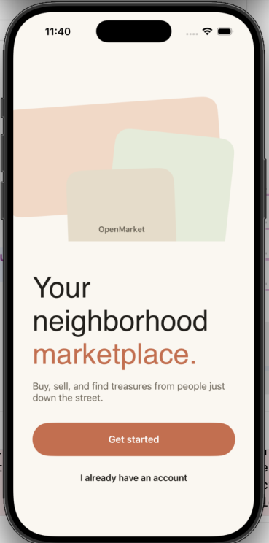 | 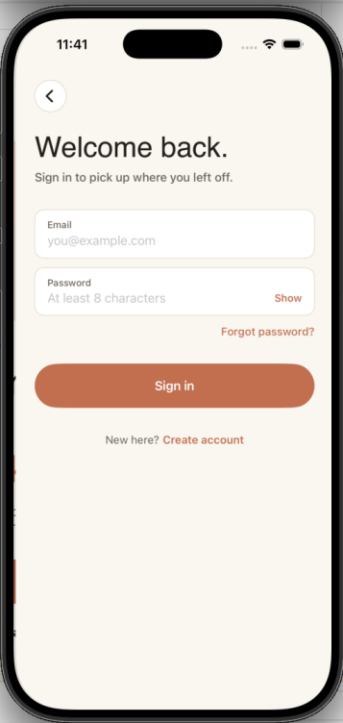
Fig. 1. Login and Registration Screens
2) Home Feed and Discovery:
HomeView presents a personalised greeting, a search bar with filter access, category quick-access chips for all nine product categories, a horizontally-scrolling 'Recently Viewed' section, a GPS-powered 'Nearby Items' section, and a paginated main product feed. Each product card displays the primary image, title, BHD price, location, and condition badge.
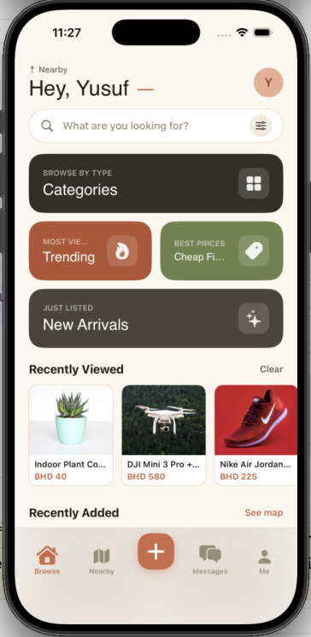 | 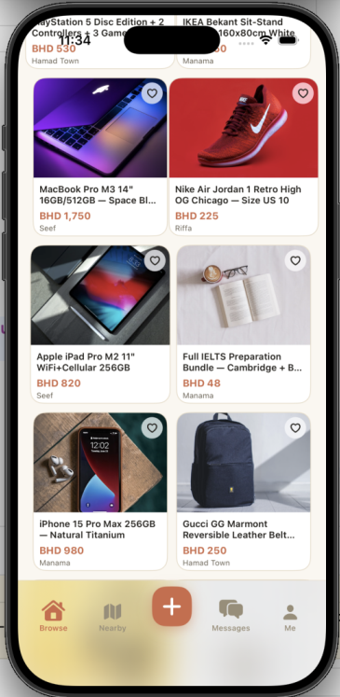
Fig. 2. Home Feed — Browse and Recently Added Sections
3) Search and Filtering:
SearchView delivers live results as the user types, with a persistent search history stored in UserDefaults. The filter sheet (FilterSheetView) exposes category, condition, BHD price range, and location radius sliders. All filters are applied without leaving the current screen. CategoryBrowserView displays all nine categories as illustrated cards, each leading to a pre-filtered CategoryProductsView.
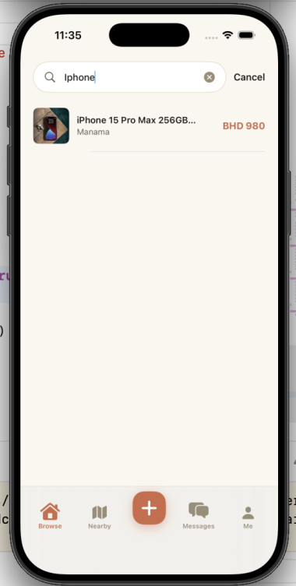 | 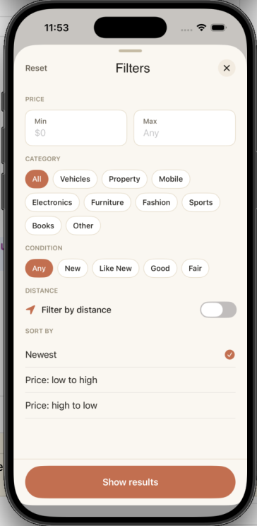 | 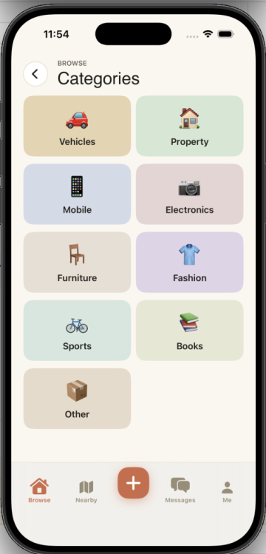
Fig. 3. Search Results, Filter Sheet, and Category Browser
4) Product Detail View:
ProductDetailView hosts a full-bleed image carousel, title, BHD price, condition badge, location, seller avatar with ratings summary, and review excerpts. Action buttons allow the buyer to Make an Offer, Message the seller, or Add to Favourites. A 'Report Listing' option is accessible via the ellipsis menu.
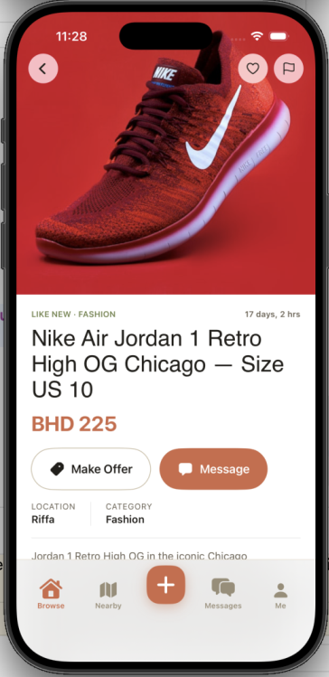
Fig. 4. Product Detail View
5) Offer and Negotiation System:
MakeOfferView allows buyers to submit a custom amount and optional note. Sellers manage incoming offers in AllIncomingOffersView with Accept, Decline, and Counter actions. Buyers receive counter-offers and can accept or decline, completing a full negotiation loop. MyOffersView shows buyers a history of all their submitted offers enriched with listing titles and seller names.
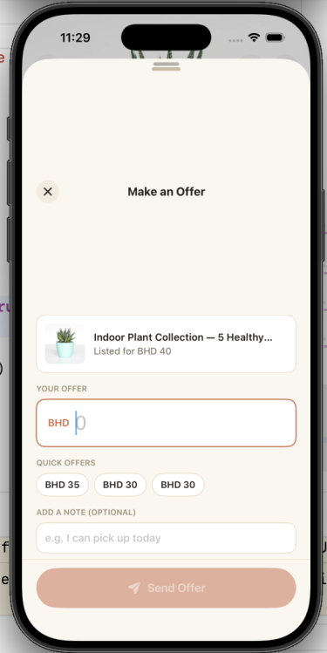 | 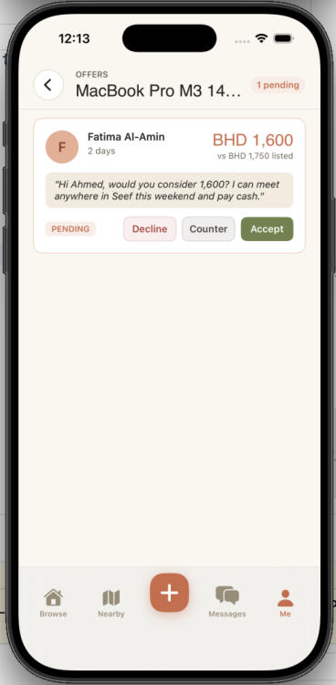 | 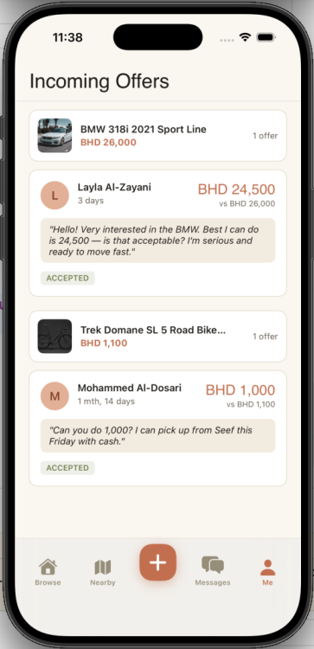 | 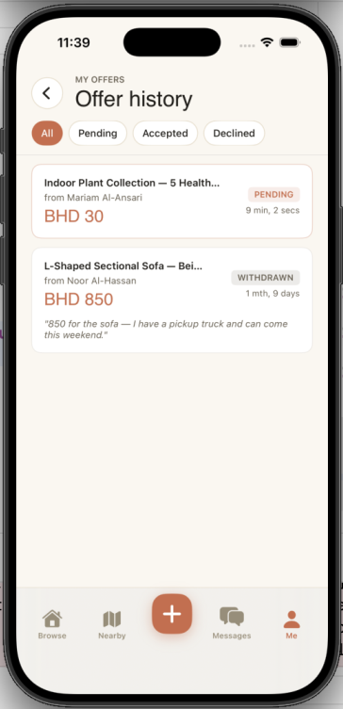
Fig. 5. Offer Workflow — Buyer Offer, Seller Response, Incoming Offers, Offer History
6) Messaging:
ConversationsView lists all active threads sorted by recency. ChatView delivers messages in real time via WebSocket. Offline recipients receive an APNS push notification as a fallback. Message bubbles follow iOS iMessage visual conventions with sender alignment.
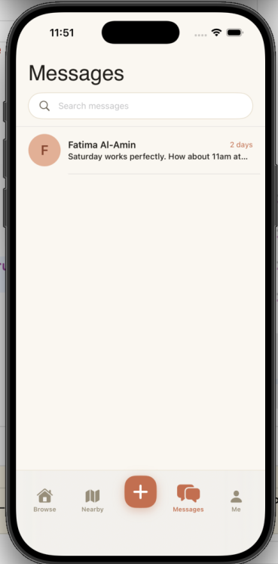 | 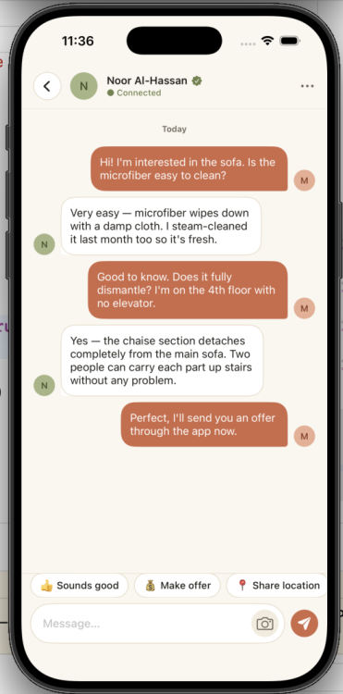
Fig. 6. Conversations List and Chat View
7) Map View:
MapView renders all nearby listings as annotation pins on a MapKit map. Tapping a pin reveals a card preview with the product photo, title, and price. A radius filter allows users to narrow results from 1 km to 50 km.
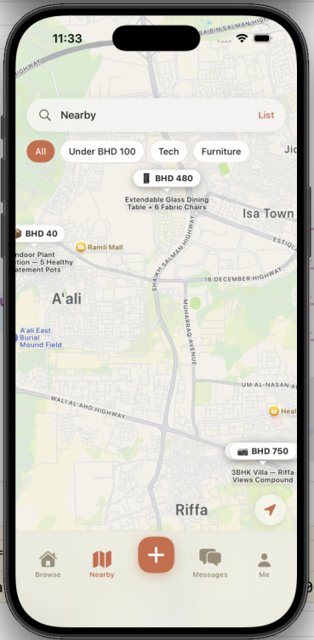
Fig. 7. Map View with Nearby Listings
8) Favourites:
FavoritesView displays saved items in a two-column grid. Items can be removed with a long-press or from the product detail page. The list persists across sessions via the back-end API with a unique composite index on (user_id, listing_id).
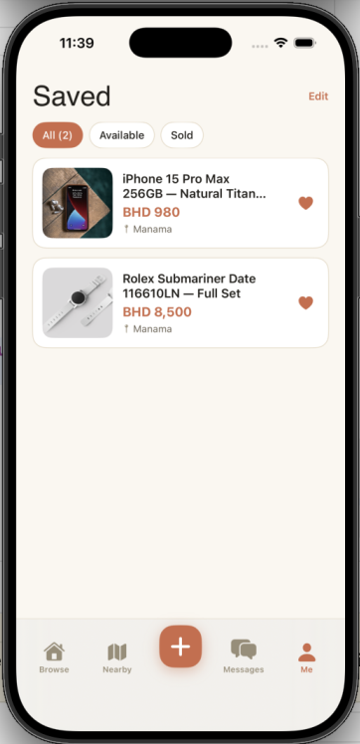
Fig. 8. Favourites View
9) Add and Edit Listing:
AddProductView guides sellers through a multi-section form covering up to five photos (with file-size validation), title, description, category picker, condition selector, BHD price, and an interactive location pin via LocationPickerView. Partial entries are auto-saved as a draft. EditListingView reuses the same form pre-populated with existing data.
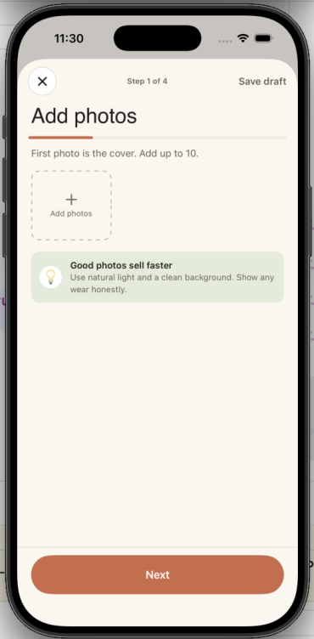 | 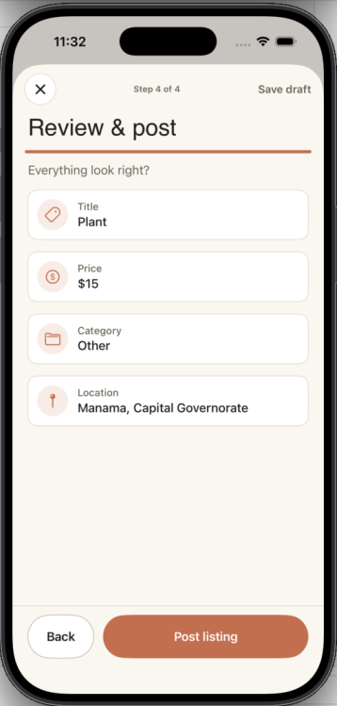 | 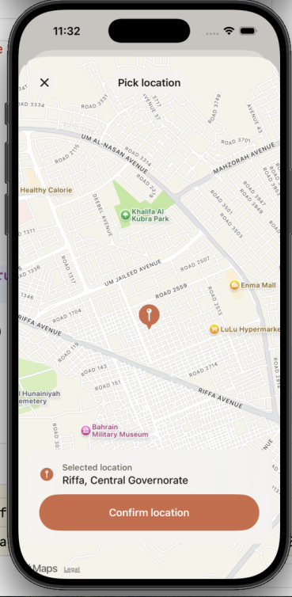 | 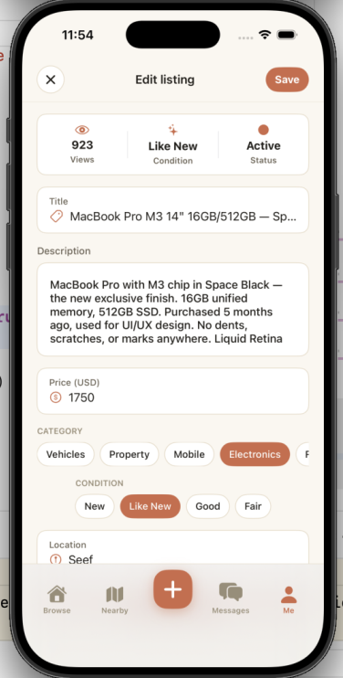
Fig. 9. Add Product Form — Steps and Location Picker; Edit Listing View
10) My Listings and Mark as Sold:
MyListingsView displays the seller's active and sold items. Tapping 'Mark as Sold' opens SoldConfirmationSheet, which optionally links the sale to an existing buyer from the offers list, then transitions the listing to a 'Sold' visual state.
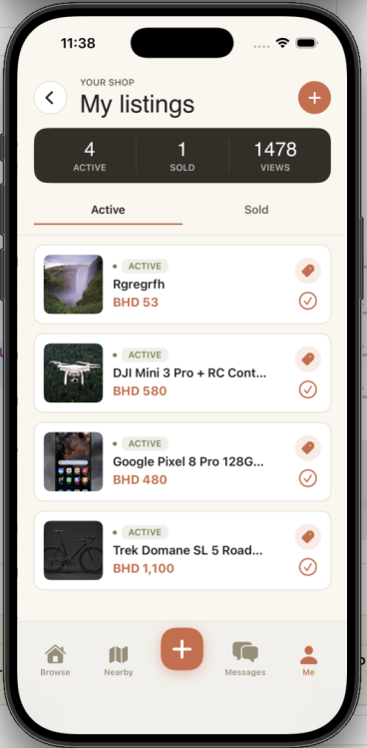 | 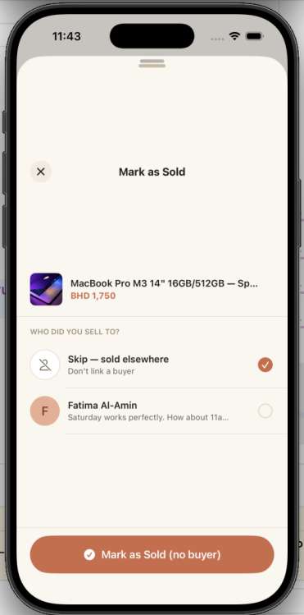
Fig. 10. My Listings and Mark as Sold Sheet
11) Seller Profile and Reviews:
SellerProfileView displays the seller's average star rating, total review count, and active listings. ReviewsView renders individual review cards with reviewer name, star rating, comment, and date. RateSellerView provides an interactive 5-star control and comment field.
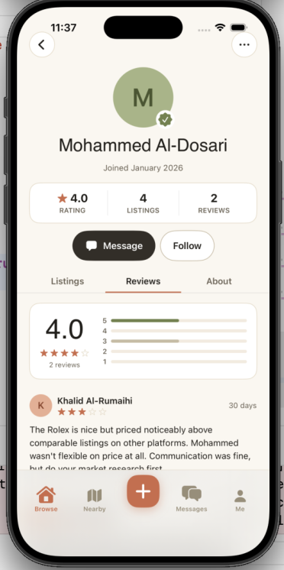 | 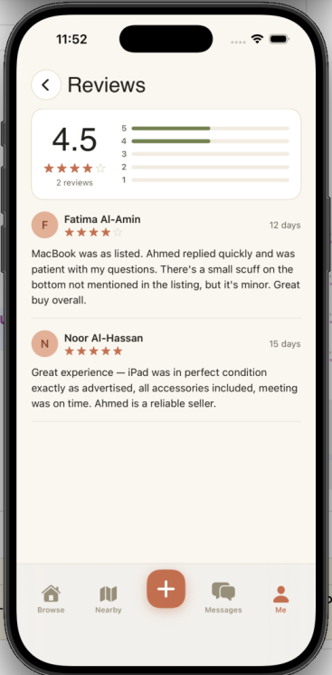
Fig. 11. Seller Profile and Reviews Screen
12) Profile and Settings:
ProfileView aggregates the user's statistics and shortcuts to all account features. PersonalInfoView allows updating the display name. NotificationsView uses @AppStorage for persistent toggle persistence. PrivacySecurityView surfaces blocked users and account deletion. HelpCenterView and TermsView provide in-app support documentation.
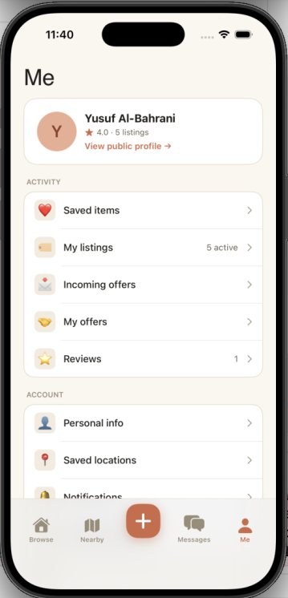 | 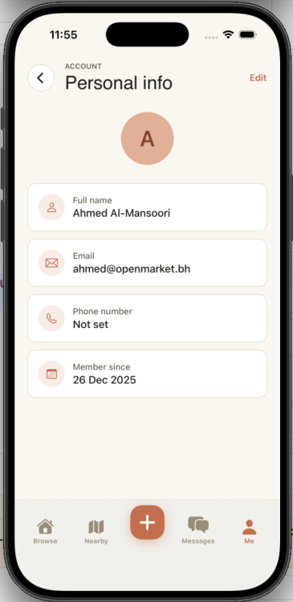 | 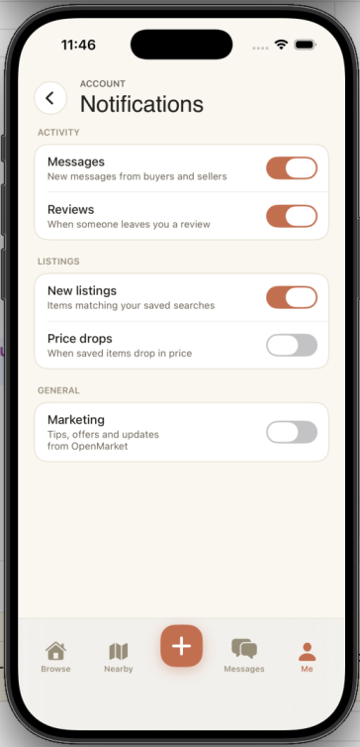 | 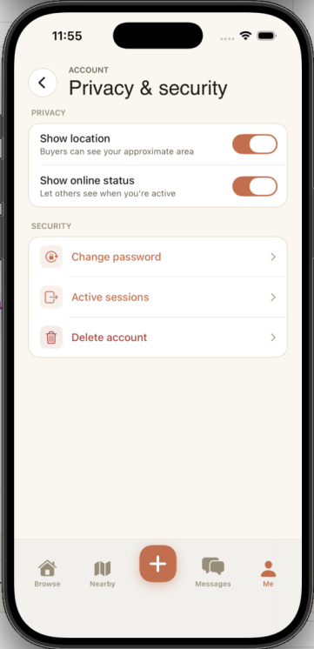
Fig. 12. Profile, Personal Info, Notification Settings, Privacy and Security
13) Report Listing:
ReportListingView collects a reason category and optional detail text before submitting to the /reports endpoint. Reports are stored against the listing and user ID for administrator review.
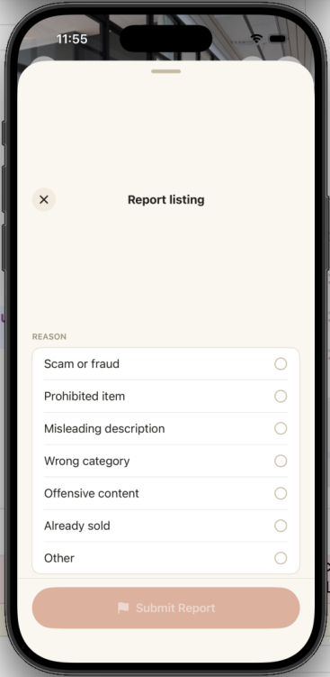
Fig. 13. Report Listing View

IV. IMPLEMENTATION DETAILS
A. User Authentication
Authentication is handled by AuthViewModel, which orchestrates calls to AuthService. On successful login or registration, the server returns a JWT token signed with HS256 (72-hour expiry) alongside the user object. The token is written to the iOS Keychain via KeychainHelper. On subsequent app launches, fetchMe() restores the session by reading the stored token and calling GET /auth/me. If the token is invalid or expired, the user is silently redirected to LoginView. All outbound API requests inject the Bearer token via the Authorization header in APIClient.request().
B. Product Listing and Discovery
ProductListViewModel drives HomeView and SearchView through a unified applyFilters() method that routes to either the text-search endpoint (/products/search with category, condition, and price-range parameters) or the location-based endpoint (/products/nearby with lat/lng and radius), depending on whether the user has enabled 'Show Nearby Only'. Results are paginated at 20 items per page. Sold items are sorted to the bottom of the feed client-side after fetching, preserving freshness ordering for active listings.
C. Product Creation and Image Upload
AddProductViewModel manages a multi-step form with automatic draft persistence to UserDefaults. Before submission, uploadImages() encodes each UIImage as JPEG at 0.8 quality and posts it as multipart/form-data to /upload, which stores the file and returns a hosted URL. The listing record is only created after all images are successfully uploaded, ensuring product records always reference valid image URLs. Client-side validation rejects images exceeding 5 MB before the upload request is dispatched.
D. Offer and Negotiation System
The offer workflow implements a state machine across five statuses: pending, accepted, declined, countered, and withdrawn. The server enforces business rules: buyers cannot make offers on their own listings, duplicate active offers are rejected, and accepted offers atomically transition all other pending offers on the same listing to 'declined' within a database transaction. The iOS Offer model carries enriched BuyerName, ListingTitle, and SellerName fields populated by server-side JOINs against the listings and users tables.
E. Real-Time Messaging
ChatViewModel manages both the REST message history (GET /conversations/:id/messages) and a persistent WebSocket connection to GET /ws, authenticated via a token query parameter. Outbound messages are sent via POST /messages and simultaneously broadcast through the server-side WebSocket Hub if the recipient is online. The Hub (hub/hub.go) uses a sync.RWMutex-protected map keyed by user ID to safely manage concurrent goroutines. If the recipient is offline, Hub.Send() returns false and the server dispatches an APNS push notification. ChatViewModel reconnects automatically on network interruption by observing URLSessionWebSocketTask delegate callbacks.
F. Location Services and Maps
LocationService is a singleton CLLocationManagerDelegate that publishes currentLocation and authorizationStatus as @Published properties. On first launch, the app requests 'When In Use' location permission with a contextual explanation string. MapView renders an MKMapView with annotation pins for every nearby product. LocationPickerView lets sellers drag a pin or geocode an address to set the listing location.
G. Ratings and Reviews
ReviewService wraps three endpoints: POST /reviews (submit), GET /users/:id/reviews (list with aggregate), and DELETE /reviews/:id (remove). The server enriches each review response with the reviewer's display name via a JOIN on the users table. ReviewsResponse carries sellerID, averageRating (Float), reviewsCount, and a reviews array. StarRatingView renders an interactive or read-only 5-star control used in RateSellerView, ProductDetailView, and SellerProfileView.
H. Data Models
Table II summarises the core data models, their key fields, and entity relationships across the iOS Swift layer and the Go back-end GORM layer.
TABLE II. DATA MODEL SUMMARY
Model | Key Fields | Relationships
User | id, name, email, passwordHash, createdAt | Has many Listings, Reviews, Messages, Favorites
Listing | id, title, description, price, category,  condition, location, lat/lng, images[], isSold | Belongs to User; has many Offers, Reviews, Favorites
Offer | id, listingID, buyerID, sellerID, amount,  status, counterAmount, createdAt | Belongs to Listing and two Users
Message | id, senderID, receiverID, content, createdAt | Belongs to two Users
Review | id, rating, comment, sellerID, reviewerID | Belongs to Seller and Reviewer
Favorite | id, userID, listingID | Unique pair of User and Listing
Block | id, blockerID, blockedID, createdAt | Unique pair of two Users
Report | id, listingID, userID, reason, details | Belongs to Listing and reporting User
DeviceToken | id, userID, token, platform | Belongs to User

I. API Endpoint Summary
Table III lists the 34 REST API routes exposed by the Go back-end, the authentication requirement for each, and a brief description.
TABLE III. REST API ENDPOINTS
Method + Route | Auth | Description
POST /auth/register | No | Create account, return JWT + User
POST /auth/login | No | Authenticate, return JWT + User
GET /auth/me | Yes | Fetch current user profile
PATCH /auth/profile | Yes | Update display name
POST /products | Yes | Create new listing
GET /products | Yes | Paginated feed with search/sort
GET /products/:id | Yes | Single product details
PUT /products/:id | Yes | Update listing
PATCH /products/:id/sold | Yes | Mark listing as sold
DELETE /products/:id | Yes | Delete listing
GET /products/search | Yes | Filtered search (category/condition/price)
GET /products/nearby | Yes | Location-based product search
POST /offers | Yes | Submit purchase offer
GET /offers/my | Yes | Buyer offer history (enriched)
GET /products/:id/offers | Yes | Seller view of offers on listing
PATCH /offers/:id | Yes | Seller: accept/decline/counter
PATCH /offers/:id/buyer | Yes | Buyer: respond to counter offer
DELETE /offers/:id | Yes | Withdraw offer
POST /messages | Yes | Send message (REST + WebSocket + push)
GET /conversations | Yes | List all conversations
GET /conversations/:id/messages | Yes | Full message history with user
GET /ws | Yes | WebSocket endpoint (token in query)
POST /reviews | Yes | Submit seller review (1-5 stars)
GET /users/:id/reviews | Yes | Seller reviews with aggregate rating
DELETE /reviews/:id | Yes | Delete review
POST /favorites/:productId | Yes | Add product to favourites
DELETE /favorites/:productId | Yes | Remove from favourites
GET /favorites | Yes | List all favourite products
POST /users/:id/block | Yes | Block user
DELETE /users/:id/block | Yes | Unblock user
POST /reports | Yes | Report listing
POST /upload | Yes | Upload product image (multipart)
POST /devices | Yes | Register APNS device token
DELETE /devices | Yes | Deregister device token on logout

V. TESTING AND VALIDATION
A. Unit Testing
Unit tests were written for the Go back-end business logic layer under backend/tests/ using the standard testing package. Each handler's validation logic was tested in isolation.
- TestCreateOffer_PreventsSelfOffer — buyers cannot make offers on their own listings.
- TestCreateOffer_PreventsDuplicateActiveOffer — one active offer per buyer per listing.
- TestRespondToOffer_StateTransitions — all valid and invalid status transitions verified.
- TestJWT_GenerateAndParse — token generation and claim extraction verified.
- TestBcrypt_HashAndVerify — password hashing and comparison verified.
- TestCategoryValidation — nine-category whitelist enforced correctly.
B. Integration Testing
Integration tests exercised the full HTTP request-response cycle by spinning up an in-memory SQLite instance and registering the Gin router. Each scenario performed the complete operation sequence from user registration through to the target action.
- Authentication flow: register -> login -> /auth/me session restore.
- Listing lifecycle: create -> browse -> search -> filter -> mark as sold -> delete.
- Offer lifecycle: submit -> counter -> buyer accept -> listing state locked.
- Messaging: send message -> receive via WebSocket -> conversation list updated.
- Favourites: add -> list -> remove -> list empty confirmed.
- Reviews: submit -> aggregate updated -> delete -> aggregate recalculated.
- Block: block user -> cannot message -> unblock -> messaging restored.
C. User Acceptance Testing
Manual end-to-end testing was conducted on iOS Simulator (iPhone 16 Pro, iOS 18) and physical devices. Table IV presents the results for each core user story.
TABLE IV. USER ACCEPTANCE TEST RESULTS
User Story | Test Procedure | Result
Search by category and price | Open app, apply category + max-price filter | PASS
Post listing with photos | Fill form, upload 3 photos, submit | PASS
Contact a seller via chat | Open listing, tap Message, send message | PASS
Make and negotiate an offer | Make offer, seller counters, buyer accepts | PASS
View items on a map | Open Map tab, allow location, tap pin | PASS
Rate a seller after purchase | My Offers, accepted offer, 5-star review | PASS
Save items to favourites | Tap heart on listing, verify in Favourites tab | PASS
Register and log in | Create account, verify home feed loads | PASS

D. Input Validation
- Email: RFC-5321-compliant regex validated on both client and server.
- Password: minimum 8 characters enforced on client and server.
- Listing title: maximum 255 characters; description maximum 2,000 characters.
- Price: must be a positive number greater than zero.
- Images: file size must not exceed 5 MB; JPEG compression applied at 0.8 quality.
- Review rating: integer between 1 and 5 inclusive.
- Category: server rejects any value outside the nine-item approved whitelist.
VI. CHALLENGES AND SOLUTIONS
A. Real-Time Messaging with Offline Fallback
Maintaining WebSocket connections reliably across iOS background/foreground transitions proved complex, as the socket would silently drop on app backgrounding, causing missed messages. ChatViewModel was updated to detect connection state changes via the URLSessionWebSocketTask delegate and automatically reconnect on foreground transition. For offline recipients, Hub.Send() returns false when no active socket exists for the user, triggering an APNS push notification as a fallback, ensuring delivery regardless of connection state.
B. Offer State Machine Consistency
Early builds allowed race conditions where two buyers could hold simultaneous 'pending' offers on the same listing, leaving the data in an inconsistent state when one was accepted. The back-end was updated to transition all other pending offers to 'declined' atomically within a database transaction whenever an offer is accepted, guaranteeing exactly one accepted offer per listing.
C. Enriching Offer Records with Context Data
The MyOffersView initially displayed only offer amounts and status codes with no contextual information, because the Offer model stored only foreign key IDs. The GetMyOffers handler was updated to JOIN against the listings and users tables in a single query, populating computed BuyerName, ListingTitle, and SellerName fields on the response. The iOS Offer model was extended with these optional String fields, defaulting gracefully when absent.
D. Currency Localisation
Initial development used USD pricing. Switching to Bahraini Dinar required updating formatting across all views, the back-end, and ensuring BHD's three-decimal-place (fils) precision was consistently applied. A systematic find-and-replace of all currency code references updated both the Swift .currency(code:) formatters and the back-end price display strings.
E. Image Upload Performance
Large images selected from the photo library caused slow uploads and occasionally exceeded server payload limits, resulting in failed listing submissions. AddProductViewModel was updated to compress UIImages to JPEG at 0.8 quality before encoding as multipart form-data. A client-side 5 MB guard was added with a user-facing error message, preventing the upload request entirely for oversized files.
F. SwiftUI Thread Safety
Network callbacks arriving on background threads attempted to mutate @Published properties directly, causing 'Publishing changes from background threads is not allowed' runtime warnings and occasional UI glitches. All ViewModels were annotated with @MainActor, ensuring every state mutation is dispatched on the main thread automatically by the Swift concurrency runtime.
VII. FUTURE ENHANCEMENTS
The following enhancements represent a natural roadmap for production deployment of OpenMarket beyond the current project scope.
- Payment Integration: Integrate a regional payment gateway such as Benefit Pay or Apple Pay to allow in-app transaction completion with escrow protection, reducing fraud risk for both parties.
- AI-Based Recommendations: A collaborative-filtering recommendation engine analysing browsing and purchase history would surface personalised product suggestions on the home feed, increasing engagement.
- Advanced Category-Specific Filters: Augment the filter sheet with make/model filters for Vehicles, bedroom/bathroom counts for Property, and brand-name search for Electronics — mirroring the specialised filters of established regional platforms.
- Video Listings: Allow sellers to attach short product demonstration videos alongside photos, increasing buyer confidence for high-value items such as vehicles and electronics.
- Verified Seller Badges: Introduce an identity verification workflow (national ID scan and selfie) to award a 'Verified' badge on seller profiles, reducing fraud and increasing buyer trust.
- Arabic Localisation: Full Arabic localisation with RTL layout support would significantly expand the application's addressable market within Bahrain and the wider GCC region.
- Seller Analytics Dashboard: Provide sellers with view counts, offer conversion rates, average response time, and total revenue metrics, enabling data-driven pricing and listing strategy decisions.
- In-App Dispute Resolution: A structured dispute workflow where buyers raise claims, attach evidence, and have an administrator mediate outcomes would significantly increase platform trust.

VIII. TEAM CONTRIBUTIONS
The project was divided into three ownership areas with all members collaborating on integration, testing, and the final presentation. Each member presented the modules they owned during the project demonstration. Version control was managed via a shared GitHub repository with feature branches and pull-request reviews before merging.
TABLE V. INDIVIDUAL TEAM MEMBER CONTRIBUTIONS
Member | Role | Key Contributions
Abdulla Madan  (S2400025) | Project Lead &  iOS/Backend Developer | - Full MVVM iOS architecture design  - JWT authentication and Keychain integration  - Offer and negotiation system (end-to-end)  - Real-time WebSocket messaging hub  - CoreLocation and MapKit integration  - Git repository management and code reviews  - Sprint planning and task coordination
Ziyad Alhajri  (F2300078) | UI/UX Designer &  Frontend Developer | - Wireframe and visual design system  - Reusable components: OMButton, OMField, ProductCard, StarRatingView  - HomeView, SearchView, FilterSheetView, CategoryBrowserView  - FavoritesView, SellerProfileView, ReviewsView  - SkeletonView loading states  - UAT on physical devices  - Screenshot capture and UI documentation
Ahmed Qarooni  (F2300082) | Backend Developer &  QA Engineer | - SQLite schema and GORM model definitions  - All Go/Gin REST handlers and route groups  - JWT middleware and bcrypt password security  - APNS push notification fallback system  - Unit and integration test suite  - Go module dependencies and server config  - Backend performance and load validation

IX. CONCLUSION
OpenMarket successfully delivers a feature-complete iOS marketplace application that meets and exceeds all nine requirements specified in the COSC 468 project brief. The application demonstrates mastery of SwiftUI's declarative UI paradigm, the MVVM architectural pattern, modern Swift concurrency (async/await, @MainActor), CoreLocation and MapKit integration, real-time WebSocket communication, and secure JWT-based authentication backed by a robust Go/Gin REST API.
Beyond the stated requirements, the team delivered an offer negotiation state machine, a seller block system, a listing report mechanism, APNS push notification fallback, form draft persistence, image upload with size validation, full BHD currency localisation, and skeleton loading states — all contributing to a polished, production-grade user experience.
The project was completed on schedule through disciplined teamwork, clear ownership boundaries, and regular collaborative code reviews, demonstrating the leadership and responsibility principles assessed under CLO C1.

. REFERENCES
[1] Apple Inc., "SwiftUI Documentation," Apple Developer Documentation, 2024. [Online]. Available: https://developer.apple.com/documentation/swiftui
[2] Apple Inc., "CoreLocation Framework," Apple Developer Documentation, 2024. [Online]. Available: https://developer.apple.com/documentation/corelocation
[3] Apple Inc., "MapKit Framework," Apple Developer Documentation, 2024. [Online]. Available: https://developer.apple.com/documentation/mapkit
[4] Apple Inc., "Keychain Services," Apple Developer Documentation, 2024. [Online]. Available: https://developer.apple.com/documentation/security/keychain_services
[5] Apple Inc., "UserNotifications Framework," Apple Developer Documentation, 2024. [Online]. Available: https://developer.apple.com/documentation/usernotifications
[6] The Go Authors, "The Go Programming Language," Google, 2024. [Online]. Available: https://go.dev
[7] gin-gonic, "Gin Web Framework," GitHub, 2024. [Online]. Available: https://github.com/gin-gonic/gin
[8] go-gorm, "GORM — The Fantastic ORM Library for Golang," 2024. [Online]. Available: https://gorm.io
[9] golang-jwt, "golang-jwt/jwt: Community maintained clone of dgrijalva/jwt-go," GitHub, 2024. [Online]. Available: https://github.com/golang-jwt/jwt
[10] SQLite Consortium, "SQLite Home Page," 2024. [Online]. Available: https://www.sqlite.org
[11] IEEE, "IEEE Editorial Style Manual for Authors," IEEE, 2024. [Online]. Available: https://ieeeauthorcenter.ieee.org

